Cindy Kevina

2121310021/TI-21-PA

02.

package praktikum4;

public class Latihan02 {

public static void main(String[] args) {

int[] num = new int[5]; num[0] = 20;

num[1] = 21;

num[2] = 8;

num[3] = 25;

num[4] = 34;

for (int i = 0; i < num.length; i++) { System.***out***.println("ages[" + i + "] = " + num[i]);

}

}

}

Output

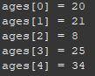

03.

package praktikum4;

import javax.swing.JOptionPane;

public class Latihan03 {

public static void main(String[] args) {

String out = "";

int jml = Integer.*parseInt*(JOptionPane.*showInputDialog*(null, "Masukkan jumlah array: ", "Input", JOptionPane.***QUESTION_MESSAGE***));

int[] num = new int[jml];

for (int i = 0; i < jml; i++) {

num[i] = Integer.*parseInt*(JOptionPane.*showInputDialog*(null, "Masukan angka : ", "Data array ke-" + i, JOptionPane.***QUESTION_MESSAGE***));

out += "x[" + i + "]=" + num[i] + "\n";

}

JOptionPane.*showMessageDialog*(null, out , "Output Array", JOptionPane.***INFORMATION_MESSAGE***);

}

}

O

Output

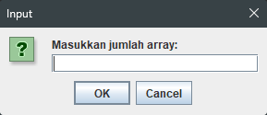

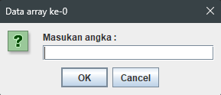

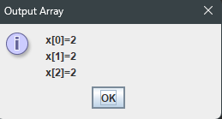

04.

package praktikum4;

import javax.swing.JOptionPane;

public class Latihan04 {

public static void main(String[] args) { String out = "";

int jml = Integer.*parseInt*(JOptionPane.*showInputDialog*(null, "Masukkan jumlah array: ", "Input", JOptionPane.***QUESTION_MESSAGE***));

int[] num = new int[jml]; int max = 0;

for (int i = 0; i < jml; i++) {

num[i] = Integer.*parseInt*(JOptionPane.*showInputDialog*(null, "Masukan angka : ", "Data array ke-" + i, JOptionPane.***QUESTION_MESSAGE***));

out += "x[" + i + "]=" + num[i] + "\n";

if (max < num[i]) {

max = num[i];

}

}

int min = max;

for(int j = 0; j < jml; j++){

if(num[j] < min){ min = num[j];

}

}

out += "Nilai terbesar adalah " + max + "\n"; out += "Nilai terkecil adalah " + min;

JOptionPane.*showMessageDialog*(null, out , "Output Array", JOptionPane.***INFORMATION_MESSAGE***);

}

}

Output

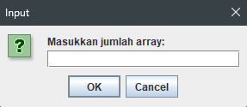

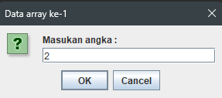

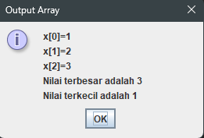

05.

package praktikum4;

import javax.swing.JOptionPane;

public class Latihan05 {

public static void main(String[] args) { String out = "";

String field[] = {"Nama Lengkap: ", "Alamat: ", "No Telp: "};

String isi[] = {"","",""};

for (int i = 0; i < field.length; i++) {

String in = JOptionPane.*showInputDialog*(null, field[i], "Data array ke-" + i, JOptionPane.***QUESTION_MESSAGE***);

isi[i] = in + "\n";

out += field[i] + isi[i];

}

JOptionPane.*showMessageDialog*(null, out , "Output Array", JOptionPane.***INFORMATION_MESSAGE***);

}

}

Output

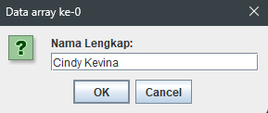

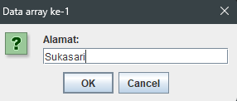

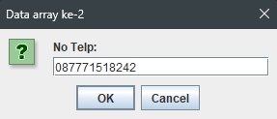

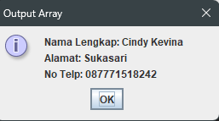

06.

package praktikum4;

import javax.swing.JOptionPane;

public class Latihan06 {

public static void main(String[] args) {

int baris =2;

int kolom =2;

int matriksA[][]= new int[baris][kolom];

int matriksB[][]= new int[baris][kolom];

JOptionPane.*showMessageDialog*(null, "==== Matriks A ====");

for(int i =0; i<matriksA.length; i++) {

for(int j=0; j<matriksA.length; j++) {

matriksA[i][j] = Integer.*parseInt*(JOptionPane.*showInputDialog*(null,"Masukkan Nilai Matriks ke-["+i+"]"+"["+j+"]", "Matriks A",JOptionPane.***QUESTION_MESSAGE***));

}

}

JOptionPane.*showMessageDialog*(null, "==== Matriks B ====");

for(int i =0; i<matriksB.length; i++) {

for(int j=0; j<matriksB.length; j++) {

matriksB[i][j] = Integer.*parseInt*(JOptionPane.*showInputDialog*(null,"Masukkan Nilai Matriks ke-["+i+"]"+"["+j+"]","Matriks B",JOptionPane.***QUESTION_MESSAGE***));

}

}

//OUTPUT

String outputA="Matriks A = \n";

for(int i=0; i<matriksA.length;i++) {

for(int j=0;j<matriksA.length; j++) {

outputA += matriksA[i][j] + " ";

}

outputA += "\n";

}

String outputB="Matriks B = \n";

for(int i=0; i<matriksA.length;i++) {

for(int j=0;j<matriksA.length; j++) {

outputB += matriksA[i][j] + " ";

}

outputB += "\n";

}

JOptionPane.*showMessageDialog*(null, outputA+outputB);

}

}

Output

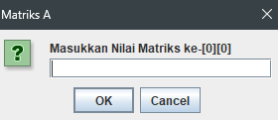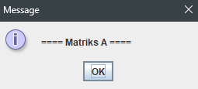

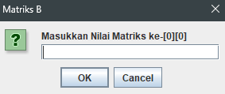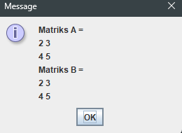

07.

package praktikum4;

import javax.swing.JOptionPane;

public class Latihan07 {

public static void main(String[] args) {

int baris =2;

int kolom =2;

int matriksA[][]= new int[baris][kolom]; int matriksB[][]= new int[baris][kolom]; int hasil1[][] = new int[baris][kolom];

JOptionPane.*showMessageDialog*(null, "==== Matriks A ====");

for(int i =0; i<matriksA.length; i++) {

for(int j=0; j<matriksA.length; j++) { matriksA[i][j] =

Integer.*parseInt*(JOptionPane.*showInputDialog*(null,"Masukkan angka: ","Matriks A ke-["+i+"]"+"["+j+"]",JOptionPane.***QUESTION_MESSAGE***));

}

}

JOptionPane.*showMessageDialog*(null, "==== Matriks B ====");

for(int i =0; i<matriksB.length; i++) {

for(int j=0; j<matriksB.length; j++) { matriksB[i][j] =

Integer.*parseInt*(JOptionPane.*showInputDialog*(null,"Masukkan angka: ", "Matriks B ke-["+i+"]"+"["+j+"]", JOptionPane.***QUESTION_MESSAGE***));

}

}

JOptionPane.*showMessageDialog*(null, "==== Hasil ====");

for(int i =0; i<hasil1.length; i++) {

for(int j=0; j<hasil1.length; j++) {

hasil1[i][j] = matriksA[i][j] - matriksB[i][j];

}

}

//OUTPUT

String outputA="Matriks A: \n";

for(int i=0; i<matriksA.length;i++) {

for(int j=0;j<matriksA.length; j++) { outputA += matriksA[i][j] + " ";

}

outputA += "\n";

}

String outputB="Matriks B: \n";

for(int i=0; i<matriksB.length;i++) {

for(int j=0;j<matriksB.length; j++) { outputB += matriksB[i][j] + " ";

}

outputB += "\n";

}

String output1="Pengurangan Matriks A: \n";

for(int i=0; i<hasil1.length;i++) {

for(int j=0;j<hasil1.length; j++) { output1 += hasil1[i][j] + " ";

}

output1 += "\n";

}

JOptionPane.*showMessageDialog*(null, outputA+outputB+output1);

}

}

Output

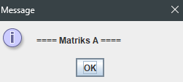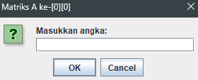

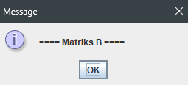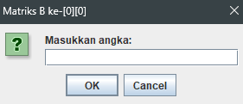

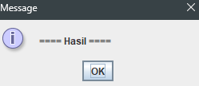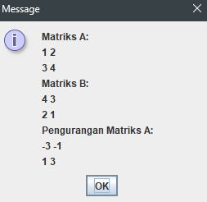

08.

package praktikum4;

import javax.swing.JOptionPane;

public class Latihan08 {

public static void main(String[] args) { int baris = 3, kolom = 4;

int end = 0, m = 1, e = 2; String output = "";

String input[][] = new String[baris][kolom]; input[0][0] = "Nama Lengkap: "; input[1][0] = "Alamat: ";

input[2][0] = "No Telp: ";

//INPUT & OUTPUT

for(int i = 0; i < baris; i++) {

output += input[i][0]; for(int j = m; j < e; j++) {

input[i][j] = JOptionPane.*showInputDialog*(null, input[i][0], "Data Array ke-[" + i + "]" + "[" + j + "]", JOptionPane.***QUESTION_MESSAGE***);

output += input[i][j] + "\n";

}

//restart loop

if (i == baris - 1) {

output += "\n"; i = -1;

m = m+1; e = e+1;

end = end+1; if (end == 3) {

i = baris;

}

}

}

JOptionPane.*showMessageDialog*(null, output);

}

}

Output

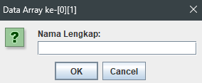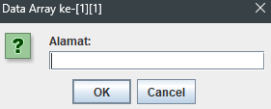

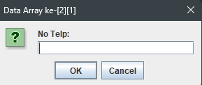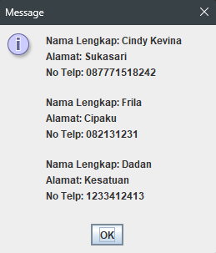

09.

package praktikum4;

import java.util.ArrayList; import javax.swing.JOptionPane;

public class Latihan09 {

public static void main(String[] args) {

String out = "";

int jml = Integer.*parseInt*(JOptionPane.*showInputDialog*(null, "Masukkan jumlah array: ", "Input", JOptionPane.***QUESTION_MESSAGE***));

ArrayList<Integer> num = new ArrayList<Integer>();

int max = 0;

for (int i = 0; i < jml; i++) {

int isi = Integer.*parseInt*(JOptionPane.*showInputDialog*(null, "Masukan angka : ", "Data array ke-" + i, JOptionPane.***QUESTION_MESSAGE***));

num.add(i, isi);

out += "x[" + i + "]=" + isi + "\n";

if (max < isi) {

max = isi;

}

}

int min = max;

for(int j = 0; j < jml; j++){

if(num.get(j) < min){ min = num.get(j);

}

}

out += "Nilai terbesar adalah " + max + "\n"; out += "Nilai terkecil adalah " + min;

JOptionPane.*showMessageDialog*(null, out , "Output Array", JOptionPane.***INFORMATION_MESSAGE***);

}

}

Output

